Article 12 — The Continuity Layer

Michal Doroszewski

The Revolving Door
You’re walking through a revolving door. A normal one — glass panels, smooth rotation, nothing unusual. You step in, push gently, and move forward. The moment you reach the other side, a loud click echoes overhead. The door stops. A red light flashes. A voice says, “Identity not confirmed. Please re‑enter.”
You step back into the door. It rotates again. You come out the same side you started on. The light turns green, then yellow, then red. The voice says, “Session expired. Please authenticate.”
You try again. The door spins faster this time, as if eager to help. You step out. A scanner beeps. The screen says, “Device posture unknown.” You blink. You haven’t changed anything. You try again. The door spins halfway, then reverses direction. The screen now says, “Location mismatch.” You try again. The door spins normally, then stops with a jolt. The screen says, “Context lost. Start over.”
Behind you, a line of people is forming — all stuck in the same loop. Some push harder. Some try different angles. Some try to time the rotation. None of it matters. The door resets every time.
You haven’t changed. Your badge hasn’t changed. Your destination hasn’t changed. The only thing that changed was the system’s ability to remember you from one rotation to the next.
That is the Continuity Problem. Not the “bad token” kind — the architectural kind. The kind that appears when cloud systems lose the signals that allow them to maintain trust across transitions. The kind that turns a revolving door into a reset machine.
[Comic Image Placeholder]

Continuity Is the Second Layer of Modernization
Visibility alone is not enough. Seeing the truth does not stabilize it. Modern cloud systems are designed to maintain trust across transitions — between locations, between devices, between refresh cycles. When those transitions fail, the system resets. The user reauthenticates. The session collapses. The trust evaporates. A system that cannot remember becomes a system that cannot function.

Why GCC‑Moderate Breaks Continuity
The FedRAMP Moderate boundary was built for static trust, not dynamic identity. That mismatch creates architectural amnesia. The system forgets the device. It forgets the location. It forgets the session. It forgets the context. It forgets the user. It does not forget because it is broken. It forgets because the architecture blocks memory.

Headquarters and Field Offices Experience Continuity Differently
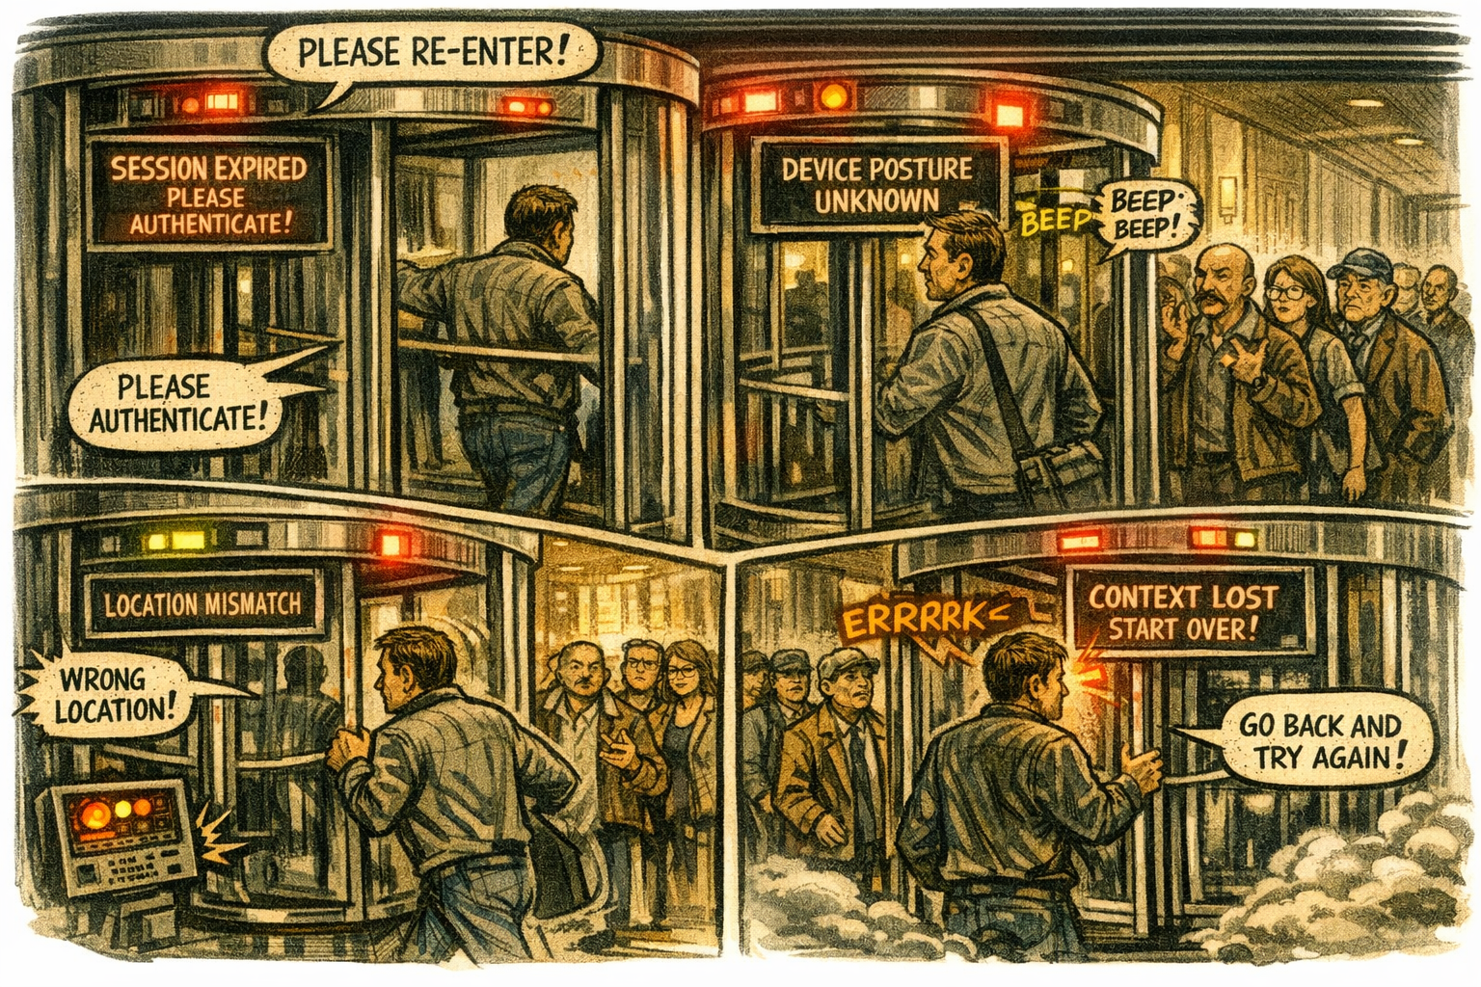
Headquarters sits close to identity controllers, token refresh endpoints, and stable paths. Sessions persist. Trust is maintained. Field offices sit behind WAN optimizers, inspection layers, and region drift. Sessions reset. Trust evaporates. The same user behaves differently. The same device is evaluated differently. The same session is treated differently. The architecture creates two realities — one continuous, one fragmented — and the system enforces both.

Why Continuity Failures Are Misdiagnosed
When continuity collapses, teams blame configuration. Security blames token lifetime. Identity blames refresh logic. Network blames latency. Operations blames region drift. Users blame the cloud. Everyone is correct. Everyone is wrong.
The failure is architectural. The boundary blocks the refresh signals. The WAN distorts the timing. The inspection layers delay continuity. The region model misleads evaluation. The system isn’t broken. It’s forgetful.

Modernization Stalls Without Continuity
Modernization depends on trust, and trust depends on stability. When continuity is missing, sessions collapse, policies misfire, devices misclassify, locations drift, users reauthenticate, and teams chase ghosts. This is not dysfunction. It is architectural forgetfulness.

The Root of the Continuity Problem
The continuity problem is not caused by bad configuration, poor governance, or user error. It is caused by an architecture that cannot maintain trust across transitions. The boundary filters refresh signals. The WAN distorts timing. The inspection layers delay evaluation. The region model misleads context. The identity platform receives partial truth.
You cannot maintain trust without continuity. You cannot enforce policy without memory. You cannot modernize identity inside a reset loop.

The Only Way Forward
Continuity must be restored. The boundary must allow refresh signals. Timing must be preserved. Region awareness must be accurate. Session context must be maintained. Device trust must be stable. Identity evaluation must be complete.
Only then can sessions persist. Only then can trust remain stable. Only then can policy behave predictably. Only then can modernization move forward without resets.

About the Author
Michal Doroszewski is a technology strategist focused on cloud architecture, identity platforms, and federal modernization. He writes about the structural and architectural forces that shape government IT, translating complex technical constraints into clear, accessible narratives for leaders and practitioners.

